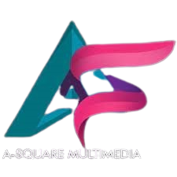
NORTH EAST MUSIC AWARDS (NEMA) FORM
NON MUSIC CATEGORIES
PLEASE USE THIS FORM TO SUBMIT NOMINATIONS FOR THE FOLLOWING CATEGORIES;
BEST GRAPHIC DESIGNER OF THE YEAR
BEST MALE ACTOR OF THE YEAR
BEST FEMALE ACTOR OF THE YEAR
BEST RADIO PRESENTER OF THE YEAR
BEST BLOGGER OF THE YEAR

FULL NAME OF STAR .............................................
STAGE NAME (IF ANY) ...........................................
CONTACT DETAILS;
CATEGORY NOMINATED FOR ....................................
PHONE NUMBER ...................................................
EMAIL ADDRESS ....................................................

